DOCUMENT 33 — 22-Language Expansion & Localization Spec
Visionary Internal · v1.0 · Language is identity, not a setting (Fix 04)

600 million Indians do not think in English. Visionary must teach in the language the
student thinks in. This requires native NLU, ASR, and script rendering, not just
translated UI strings.

1. Phase Rollout
- Phase 1 (Beta): Hindi, English, Bengali, Tamil, Telugu, Marathi (covers ~75% of
target demographic).
- Phase 2 (Year 1): Remaining 16 Schedule VIII languages.

2. Technical Stack per Language
- ASR (Speech-to-Text): Whisper fine-tuned on Indian accents. Target WER ≤8% for
Hindi/English; ≤12% for others.
- NLU (Intent/Entity): Multilingual embeddings; language detection ≥99% accuracy
before routing to LLM.
- LLM Routing: DeepSeek-R1 / Gemma-3 handle multilingual reasoning natively;
fine-tuned LLaMA (Phase 2) specifically optimized for Indic pedagogical phrasing.
- TTS (Text-to-Speech): Natural-sounding Indic voices; lip-sync not required, but
prosody must match teaching tone (patient, clear).
- UI Rendering: Noto Sans per-script. Line-height strictly 1.5 for Indic scripts
to prevent clipping of matras (vowel signs). Min font weight 400.

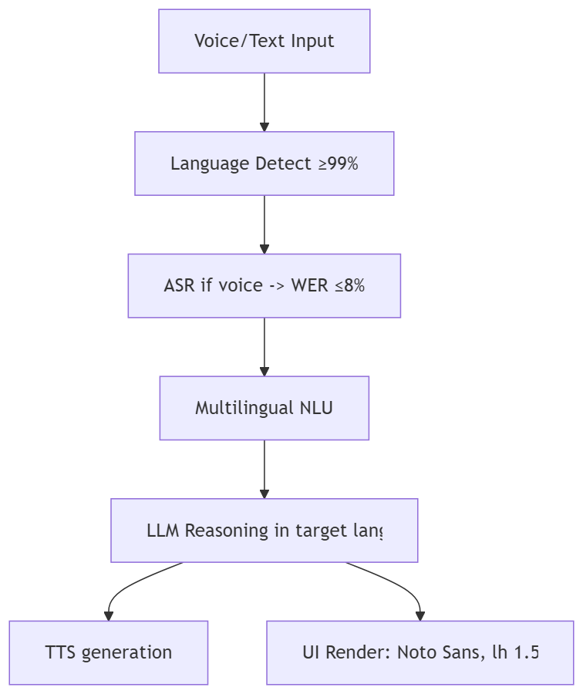

3. Rules
- The language badge (Ecoh · हिन्दी) is always visible in the top bar.
- Switching language mid-session preserves SCM state and context; it only changes the
surface rendering and LLM prompt language.
- Never fallback to English silently if the target language model fails; state the
limitation honestly in the target language.

OKF
KF1 Hindi ASR WER ≤8% on field audio · KF2 language detect ≥99% · KF3 Indic UI renders
with zero matra clipping at 360px width · KF4 mid-session language switch <500ms ·
KF5 LLM never outputs English when prompted in Hindi (unless quoting a specific term).

